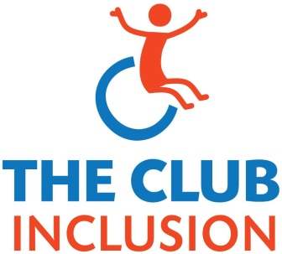

DROP IN CLUB MEMBERSHIP FORM
Please bring a signed copy to the first session
Name:

Address: Phone:

Email (for our mailing list): Birth Date:

Medical Information (ie. Allergies, Epilepsy, Asthma, Wheelchair):

Emergency Procedures:

Will you be bringing a helper /support worker? Yes / No / To begin with

Emergency Contact Name 1:

Cell phone 1: Home phone 1:
Emergency Contact Name 2:

Cell phone 2: Home phone 2:

Travels independently yes/no

Disclaimer
I [_____________________] (full name) give permission for [___________________] to take part in The
Drop In Club and related events and outings. I hereby assume all risk and release the Club Inclusion, its
organizers and volunteers, from loss, accident or injury and that all members take part at their own risk. I have provided all relevant medical details and contact details in case of emergency.

I understand that video and photography will occur during the sessions and is intended for documenting
purposes as well as for participant viewing interest. I give my permission for photos from The Club to appear on the Club Inclusion website/Facebook page: YES _____ NO _____

I have read the disclaimer and agree to these terms: YES ______N O _________

Signed by Member and/or Parent/Guardian/Caregiver (must be legal guardian or next of kin):

Member Signature______________________________________________

Parent/Guardian Signature_________________________Name (print)________________________

Relationship to member [_________________] Date: ____________________

DROP IN CLUB - Additional Information Form

(attach extra sheets if needed)

Name:

What worries you?

What calms you down?

Do you get travel sick on buses? If yes, how do you manage this?

Are you non-verbal? If yes, please tell us about the ways that you communicate.

Please tell us about your ability/willingness to go for walks outside.

Do you use a wheelchair or walking supports?

Would you like support with fine motor tasks? If so, in what way(s)?

Would you like to be reminded to use the bathroom? Yes No

Are you able/allowed to leave on your own? Yes No

Flight risk? Please tell us more:

Personal care support? Yes No

What are your particular likes and interests?

Is there anything else you would like us to know?

